**Assignment1: Validate Book ticket web page**

Validate the ‘Book ticket’ web page using Java script, which you had developed on day1. Here is the sample screen shot of same:

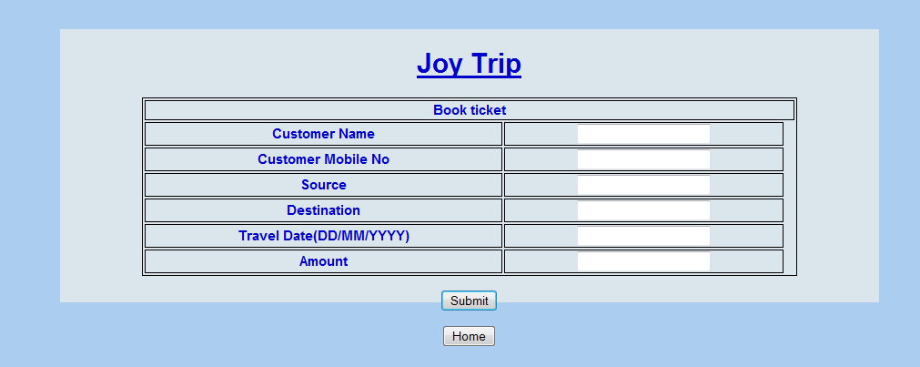

Implement following requirements using java script:

1. All fields are mandatory; ensure all fields are filled before submission. Otherwise alert with an appropriate message.
2. Customer Name:
   1. Customer name must have only alphabets and space
   2. Customer name must be minimum of 4 characters
3. Source and Destination:
   1. Source & Destination must have only alphabets and space
4. Travel Date:
   1. Validate date based on ‘DD/MM/YYYY’ format
5. Amount:
   1. Amount must have only numeric value

**Assignment2:Validate View & book schedule web page**

Validate the ‘View & book schedule’ web page using Java script, which you had developed on day1. Here is the sample screen shot of same: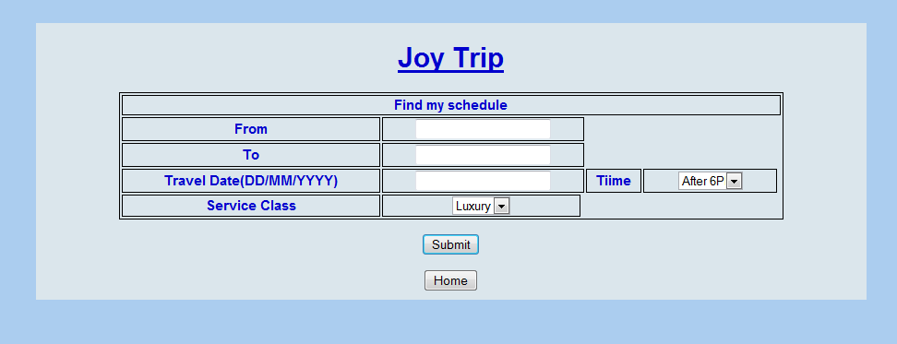

Implement following requirements using java script:

1. All fields are mandatory; ensure all fields are filled before submission. Otherwise alert with an appropriate message.
2. From and To
   1. From & TO should not have same value
3. Travel Date
   1. Validate date based on ‘DD/MM/YYYY’ format

**Assignment3: Validate View detailed schedule web page**

Validate ‘View detailed schedule’ web page using Java script, which you had developed on day1. Here is the sample screen shot of same:

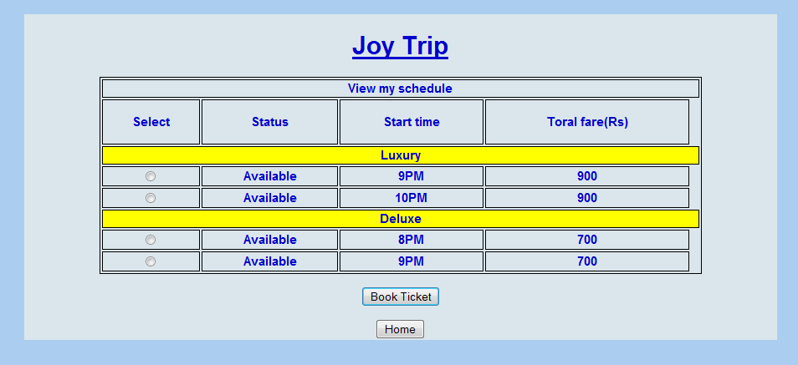

Implement following requirements using java script:

1. When user executes ‘OnClick’ event, one of radio button have been selected, otherwise alert with an appropriate message.